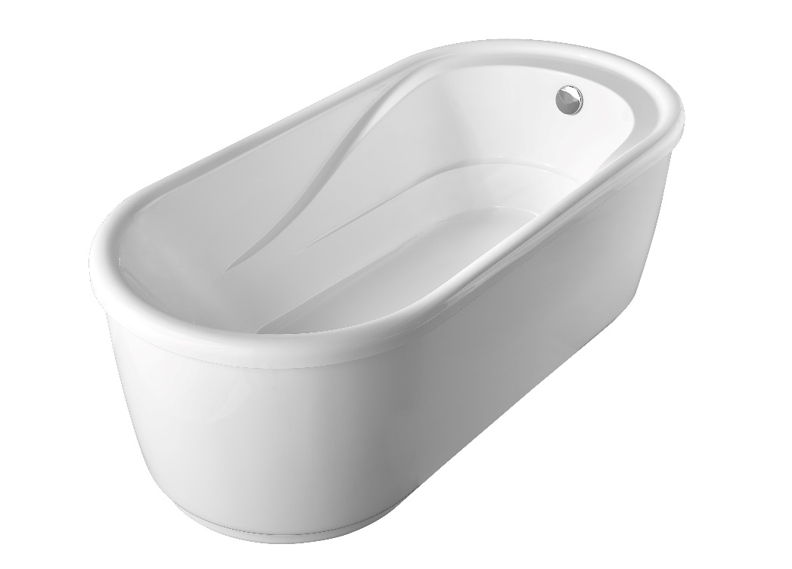

Features:
- Freestanding Tub
- Feet at the bottom of the tub
- Corner drain
- 67” (1700mm) x 32” (800mm) x 23” (580mm)

Material:
- Acrylic with reinforced FRP

Codes/ Standards:
- CSA B45.5-11/IAPMO Z124

Technical Information (All product dimensions are nominal)
INSTALLED SIZE: ____________________________________67 x 32 x23 in. (1700 x 800 x 580mm)
DRAIN LOCATION: _____________________________________________________________ Corner
WEIGHT________________________________________________________________66.1Lb. (30Kg)
CAPACITY ：__________________________________________________________ 432.1Lb. (196Kg)
GAL. TO OVERFLOW________________________________________________ 43 Gal. （196L)
BATHING WELL AT SUMP_________________________________________ 67X31 in. (1700x800mm)
BATHIING WELL AT RIM____________________________________________42X19 in.(1080x480mm)
WATER DEPTH TO OVERFLOW________________________________________ 14.4 In. (365mm)

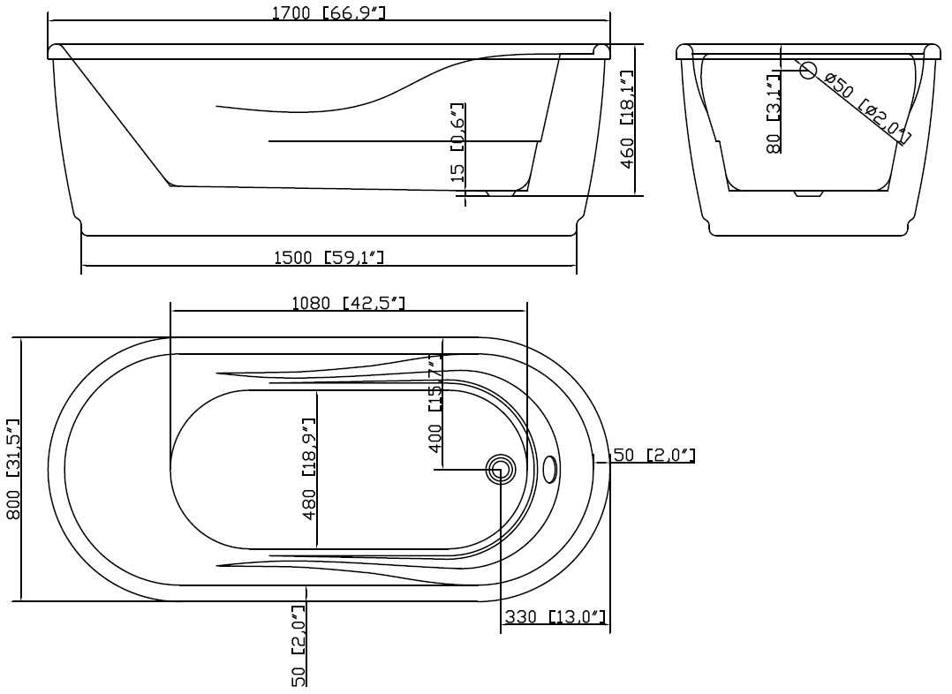

Cut Sheet of the tub

DIMENSIONS OF FIXTURES ARE NOMINAL AND MAY VARY WITHIN THE RANGE OF TOLERANCES ESTABLISHED BY ANSI STANDARDS Z124.1.2-2005

NOTES:
- Refer to the installation instructions supplied with this product for additional information.
- Provide suitable reinforcement for all supports.

IMPORTANT: Dimensions of fixtures are nominal and may vary within the range of tolerances established by ANSI standard Z124.1
These measurements are subject to change. No responsibility is assumed for use of superseded or voided leaflet.

