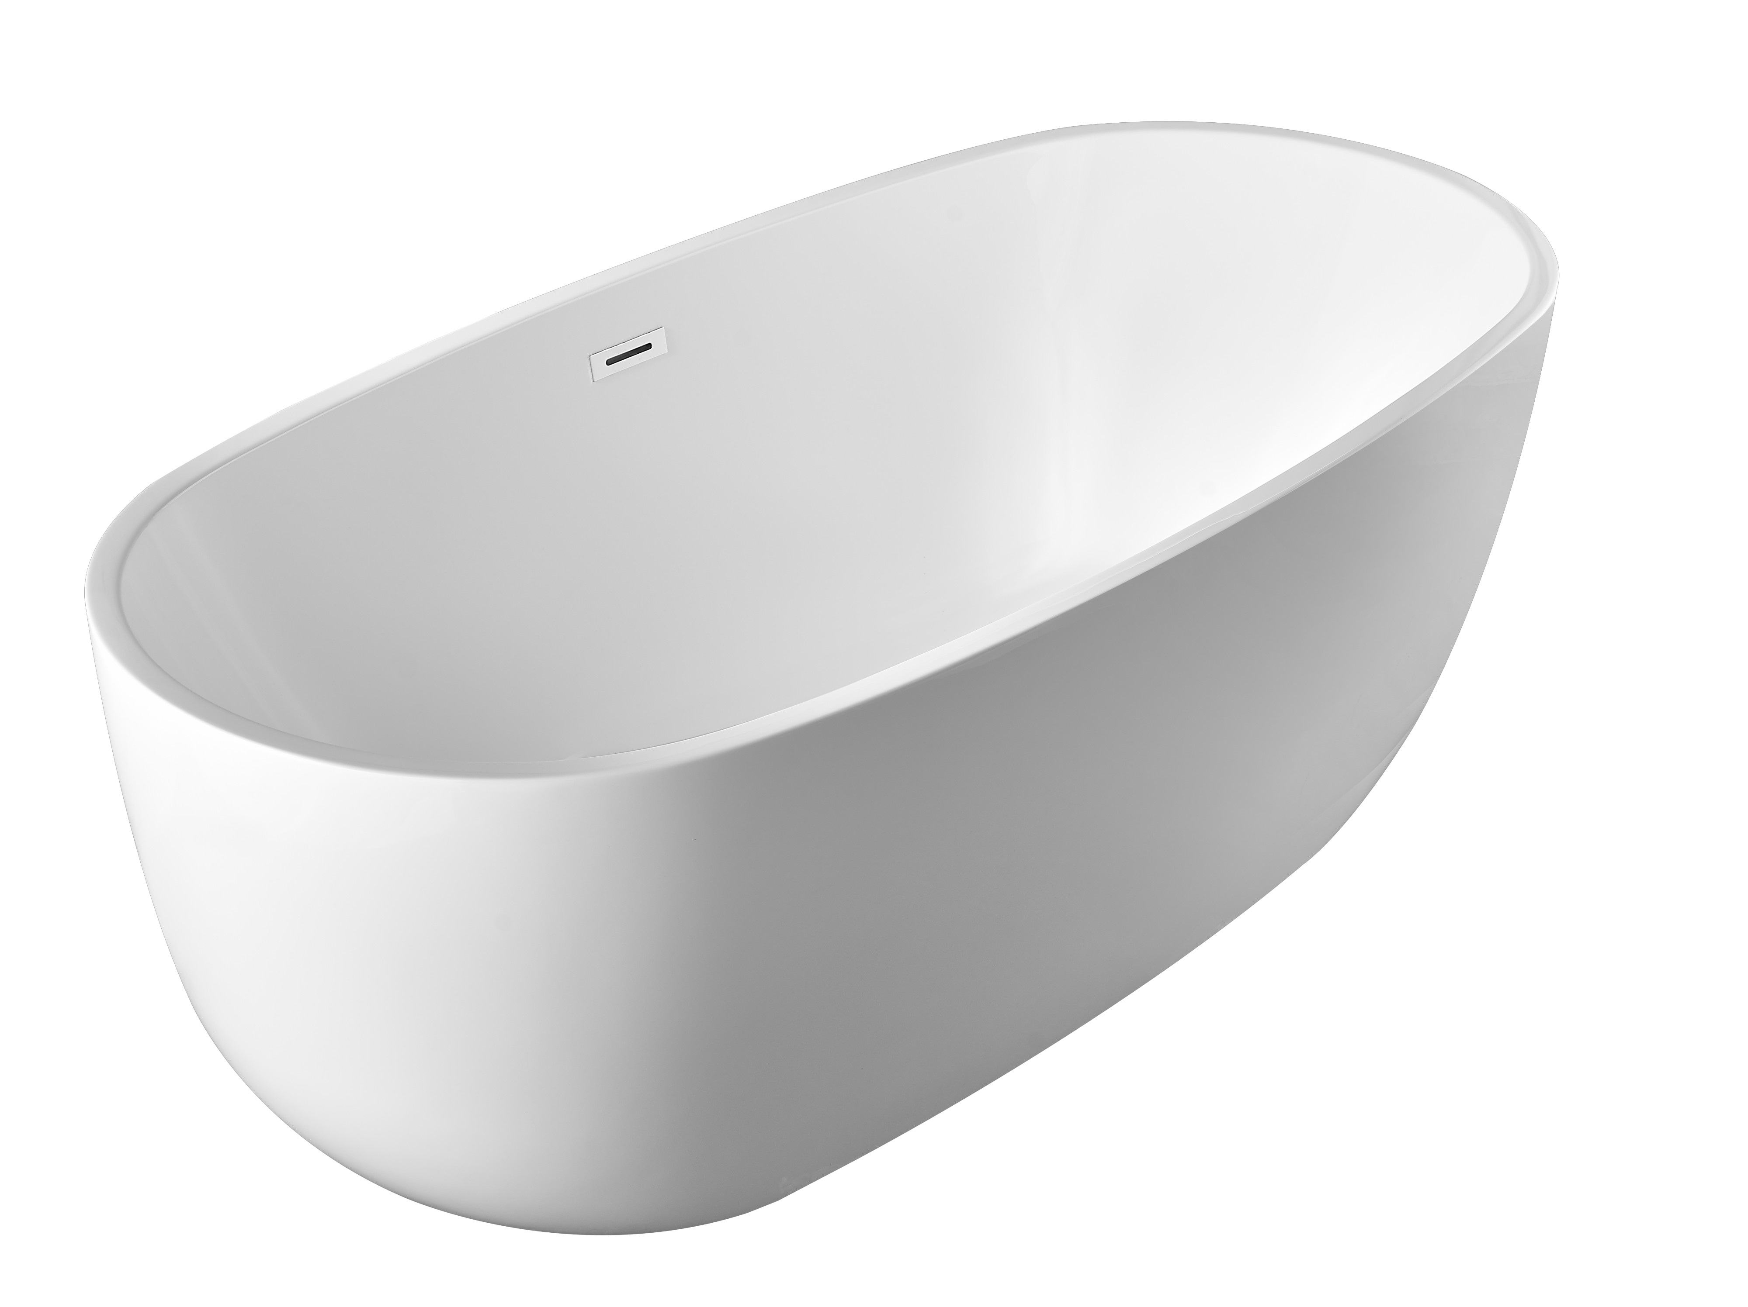

Features:
- Freestanding Tub
- Feet at the bottom of the tub
- Center drain
- 59” (1500mm) x 28” (720mm) x 23” (580mm)

Material:
- Acrylic with reinforced FRP

Codes/ Standards:
- CSA B45.5-11/IAPMO Z124

Technical Information (All product dimensions are nominal)
INSTALLED SIZE: ____________________________________59 x 28 x23 in. (1500 x 720 x 580mm)
DRAIN LOCATION: _____________________________________________________________ Center
WEIGHT________________________________________________________________66.1Lb. (30Kg)
CAPACITY ：__________________________________________________________ 385.8Lb. (175Kg)
GAL. TO OVERFLOW________________________________________________ 38 Gal. （175L)
BATHING WELL AT SUMP_________________________________________ 59X28 in. (1500x720mm)
BATHIING WELL AT RIM____________________________________________38X18 in.(980x460mm)
WATER DEPTH TO OVERFLOW________________________________________ 14.2 In. (360mm)

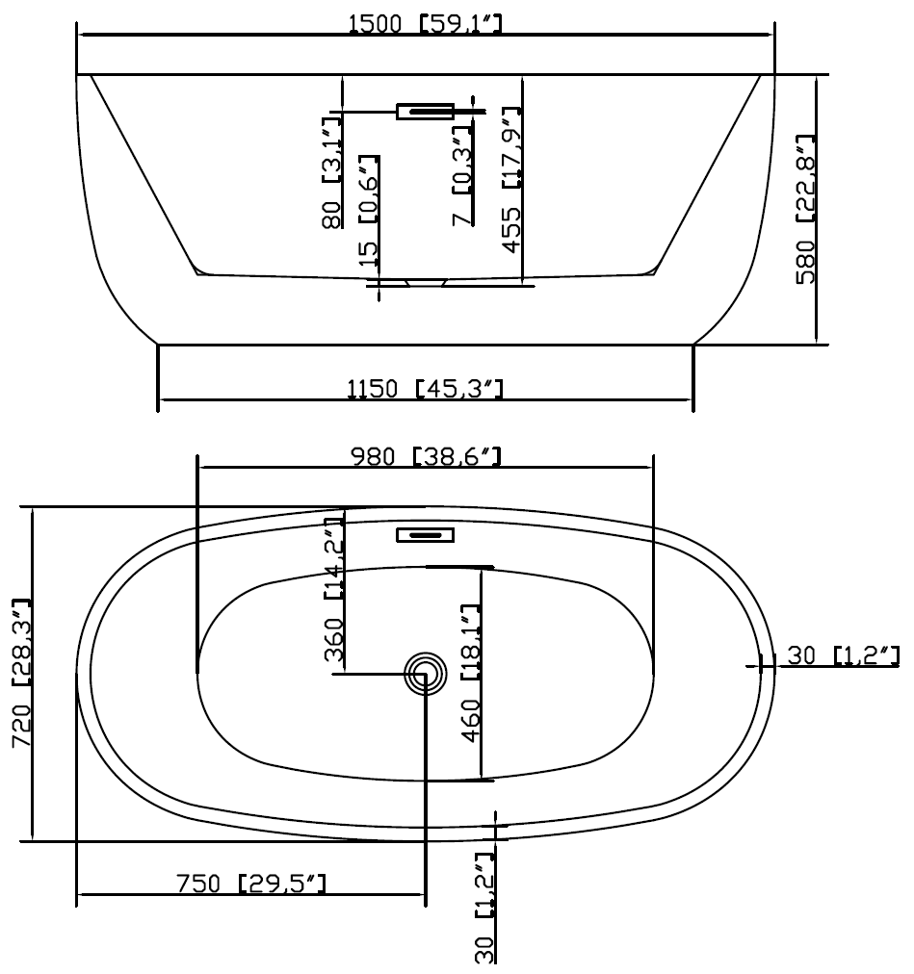

Cut Sheet of the tub

DIMENSIONS OF FIXTURES ARE NOMINAL AND MAY VARY WITHIN THE RANGE OF TOLERANCES ESTABLISHED BY ANSI STANDARDS Z124.1.2-2005

NOTES:
- Refer to the installation instructions supplied with this product for additional information.
- Provide suitable reinforcement for all supports.

IMPORTANT: Dimensions of fixtures are nominal and may vary within the range of tolerances established by ANSI standard Z124.1
These measurements are subject to change. No responsibility is assumed for use of superseded or voided leaflet.

