CONTACT US:  Dallas  909 Regal Row  Dallas, Texas 75247  214-637-3131  Grand Prairie  2725 S. State Highway 360  Grand Prairie, Texas 75052  469-263-1111  Richardson  124 E. Arapaho  Richardson, Texas 75081  214-239-3131  Lewisville  201 Marina Vista Dr. Suite 100  Lewisville, Texas 75056  469-888-4055 |  |  |  |  | Iron Door  Care, Maintenance, and Warranty
Door Basics  - All iron doors have a polyurethane spray foam insulation core. This type of insulation typically is 50% better than traditional insulation products. It also helps protect against moisture, which greatly reduces that chance of mold and mildew growth.  - All iron doors are sealed with top quality storm proof, rubber weather stripping for both insulation and weather protection.  - All iron doors are equipped with dual paned Low-e glass.  - All iron doors are equipped with glass that opens independently from the door. This allows easy cleaning and ventilation. |  |  |  |  |  |  | 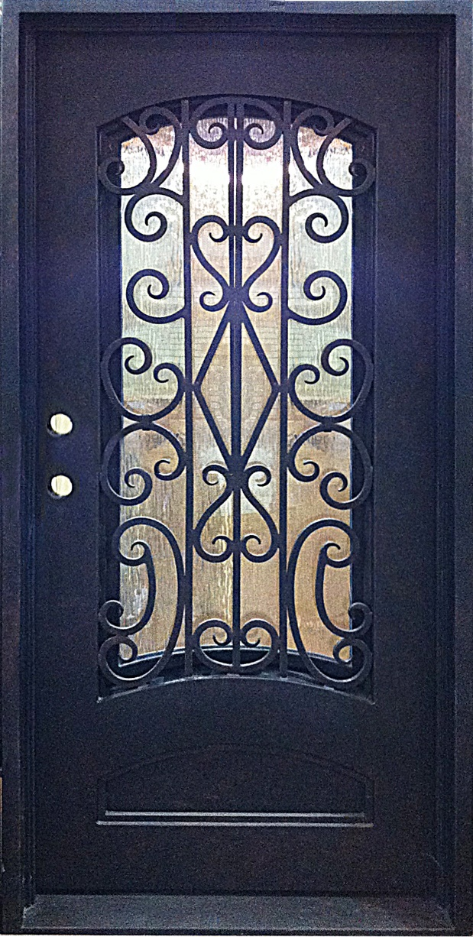
Cleaning Your Door  At Seconds and Surplus we want to keep your iron door looking beautiful. Below are the simple steps to this process:  - Make your own soap mixture to use. Plant based soap products are the only safe soaps to use on your door due to the alkalinity. To make this soap mixture use a teaspoon of liquid Castile soap and water. Stir the mixture until suds begin to form.  - Using a clean cloth, wipe the iron door with the soapy mixture. For the best results work top to bottom of your door.  - Rinse the soapy mixture off the iron door by simply spraying with a hose.  - Dry the door with a clean lint free cloth  The frequency in which your door should be cleaned depends on the area you live in. Doors installed in more humid or coastal climates will require more cleaning to prevent any problems from occurring with the finish.  Rust Removal  Iron doors that are installed in areas of high humidity or coastal regions may develop rust on the frames. It is extremely important to clean this rust in order to maintain the look and durability of the door. Below is the simple steps in removing this rust:  - Remove the rust with a wire brush. A drill with a wire brush attachment or sandpaper may also be used. All of the paint does not need to be removed just the rust  - Clean the door using the steps provided above in the cleaning section  - After a thorough cleaning, apply a rust inhibiting primer to the entire door. Follow the directions provided by the manufactuer of the primer.  - Once the primer is dry, apply the metal paint |  |  |  |  |  | 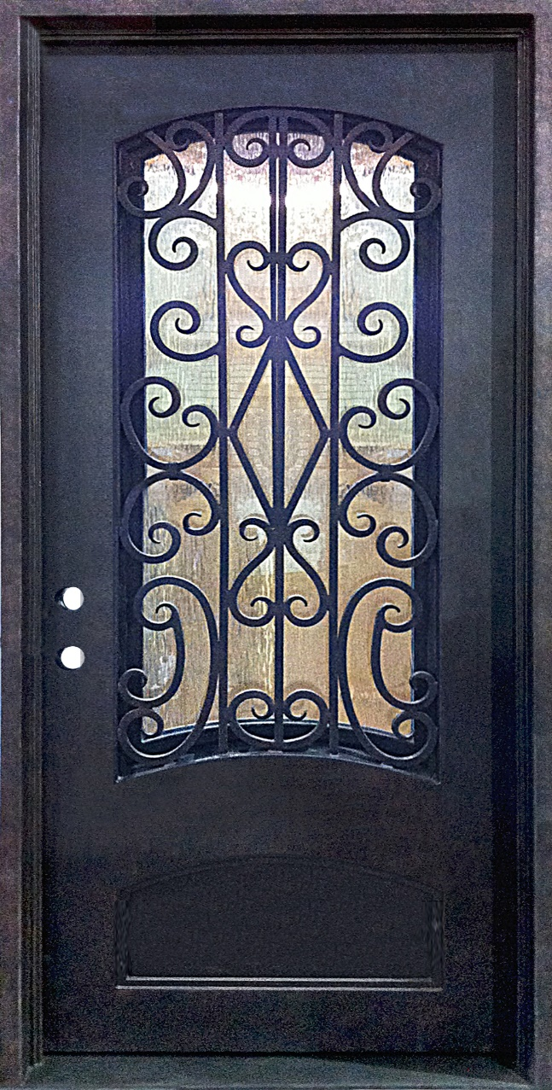

Seconds And Surplus Iron DOOR WARRANTY

What Does This Warranty Cover?
This warranty covers any and all manufacturer defects of the finish, glass or structure of all doors. for a period of 3 years from the date of purchase. Seconds and Surplus shall replace, or repair, at a place of its choosing, all defective products covered under this warranty. The warranty time limits shown above begin on the date of purchase. Warranty is void if door has not been properly installed in a building or if it is removed from its original installed location.
- Finish is warranted against flaking or peeling from normal wear and tear. All product finishes may age relative to exposure, such aging is not considered a defect and is not covered by warranty. Doors may be cleaned with a mild soap and water mixture. Cleaning with harsh chemicals including ammonia-based products (e.g. glass cleaner) may damage the finish.
- Manufacturer warrants glass from fogging as a result of normal use.

What Does This Warranty Not Cover?
This warranty does not cover the following:
- Damage due to acts of God
- Damage due to abuse
- Damage due to accidents
- Damage incurred during the installation process if installed by someone not employed by Seconds and Surplus or its recommended installers
- Iron door products exposed to below freezing temperatures may develop condensation on the interior of the door. This is dependent on the humidity level inside the building and is not considered to be a defect.
- Damage from abrasion by feet, pets, debris or other objects, damage by corrosive or reactive chemicals, whether accidental or deliberate, is not covered by warranty.
- Scratches, breakage or other damage to glass, whether accidental or deliberate, is not covered by warranty
- Seconds and Surplus assumes no liability for any labor charges regarding the installation, removal, or re-installation of doors. This warranty is strictly limited to the cost of repair or replacement of the products sold.

What is the Period of Coverage?
This warranty is effective from the date of purchase for a period of three years.

What Will We Do to Correct Problems?
- If your damaged door cannot be repaired, we will replace your damaged door. Labor charges regarding the installation, removal, or re-installation of doors will not be covered. This warranty is strictly limited to the cost of repair or replacement of the products sold.

What Will We Not Do?
- Replace or repair your damaged door due to abuse or misuse
- Replace your damaged door if it can be repaired

What Must You Do to Keep the Warranty in Effect?
- Keep all moving parts clean and free of debris
- Do not slam, kick, hit or otherwise abuse the door for other than its intended use

***Note that all products sold by Manufacturer are unique, hand crafted, works of art and as such may contain slight variations in form, functionality, and finish. Such variations are not considered defects and are not covered by warranty.

