CONTACT US:  Dallas  909 Regal Row  Dallas, Texas 75247  214-637-3131  Grand Prairie  2725 S. State Highway 360  Grand Prairie, Texas 75052  469-263-1111  Richardson  124 E. Arapaho  Richardson, Texas 75081  214-239-3131  Lewisville  201 Marina Vista Dr. Suite 100  Lewisville, Texas 75056  469-888-4055 |  |  |  |  | Fiberglass Doors  Care, Maintenance, and Warranty
Door Basics  - Allow doors to acclimate to local conditions for at least 24 hours prior to finishing  - Remove all hardware including door sweeps and weatherstripping  - Inspect all glass or glass inserts for excess sealant and carefully remove if any is present  - Mask off all glass prior to finishing  - Finish with coatings that are resistant to water, wear, heat, solvents and chemicals. Without these characteristics, the finished product may deteriorate, compromising the integrity of the product  - Use a topcoat containing a UV inhibitor. Ensure that all finishing products are made for exterior surface use. This is recommended for interior units as well as they may still be exposed to sunlight. This will provide extra protection and increased durability  - Finishing is recommended in a dust free area away from direct sunlight  - Doors must be cleaned and dry before finishing  - Finishing topcoats are recommended to be applied in several thin layers versus fewer heavier coats. If it is a wood door this will help to ensure the grain and texture is maintained  - Follow all manufacturer directions on finishing products  - Make sure to finish all six sides of the door slab including all hardware cutouts, as well as the frame on all sides, and any trim that will be used.  - All door sweeps should be sealed on both ends after attached at the end of finishing. |  |  |  |  |  |  | 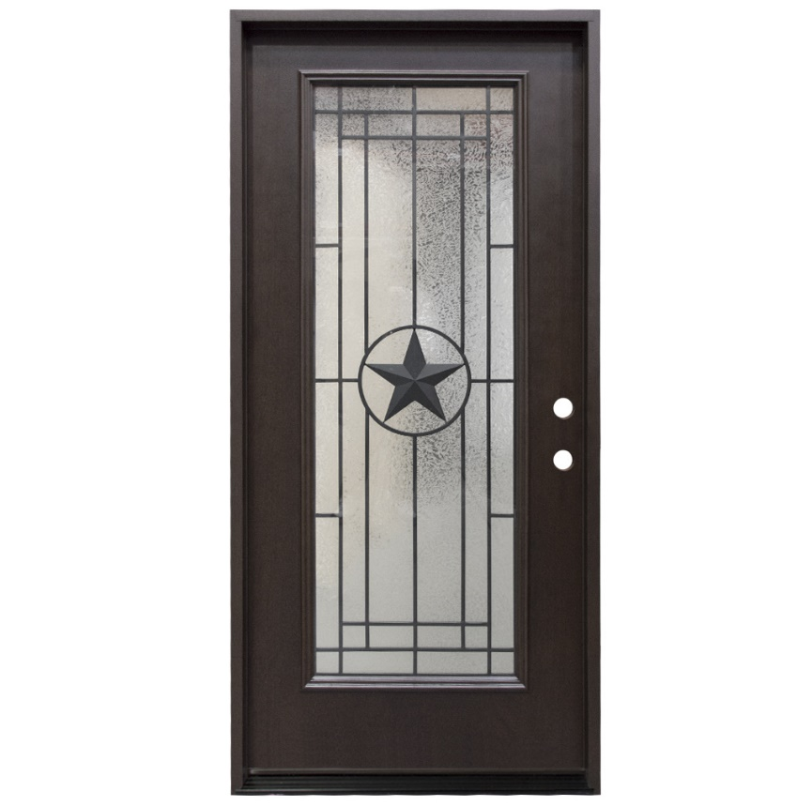
Fiberglass Doors  Smooth or Textured Fiberglass Painting  1. Clean the door with a clean, lint-free cloth, removing all dust and foreign debris. Allow the door to dry thoroughly. DO NOT USE SANDPAPER OR LACQUER THINNER.  2. Paint all six sides of the door, jamb and molding with a good quality exterior water-based 100% acrylic latex or solvent-based paint. Spray applications work best. To simulate a traditional stile and rail door look when using a paintbrush, paint the panels first, then across all the rails from one edge of the door to the other. Then paint the stiles from the top of the door to the bottom. The door can also be rolled for a stipple look. For best results, apply multiple light coats.  Smooth or Textured Fiberglass Staining  1. Clean the door with a clean, lint-free cloth, removing all dust and foreign debris. For light cleaning, a one-part vinegar to ten parts water mixture can be used. For tough dirt removal, use denatured alcohol making sure all residue is removed by turning the cloth often while cleaning. Allow the door to dry thoroughly.  2. Seal an un-primed door slab with a good quality water based primer.  3. Paint all six sides of the door, jamb and molding with a good-quality exterior water-based 100% acrylic latex or solvent-based paint. Interior door or trim paint may be used on interior doors and interior surfaces of exterior doors. Spray applications work best. To simulate a traditional stile and rail door look when using a paintbrush, paint the panels first, then across all the rails from one edge of the door to the other. Then paint the stiles from the top of the door to the bottom. The door can also be rolled for a stipple look. For best results, apply multiple light coats |  |  |  |  |  | Add a picture caption here. Add your text here.
Warranty

Door Warranty
All doors are warranted for TWO (2) years from the date of shipment to be of good material and workmanship, and to be free from defects at the time of shipment that would render them unfit for the purpose for which each door is recommended. Should the warranted door be found to contain defects as stated above, Seconds and Surplus will at its option, either (1) repair any door without charge, or (2) replace any door without, or (3) refund the price received for the door. Under the terms of this warranty, our obligation is to replace the defective product. No labor, installation, finishing and/or consequential damages will be covered. 1. Doors must be installed providing protection from exposure; typically, with a standard overhang extending outward and to the sides by a distance equal to one-half its height from the bottom of the door up to the overhang to be covered by this warranty. 2. Any deterioration caused by failure to protect and seal all exposed surfaces and edges of the door either prior to or immediately after hanging are not covered by this warranty. For continued protection, the finish needs to be maintained annually. 3. Seconds and Surplus may require that an inspection be made by one of our employees and/or partners prior to adjustment or replacement. 4. Variations in color, texture, grain or the general surface appearance of wood naturally occurring and not considered defects. 5. Any condition or problem caused by failure to follow proper handling, finishing and installation are not covered by this warranty, such as installing in full exposure to sun or sprinklers and behind storm doors. 6. The appearance of field-finished doors is not covered by this warranty in any event.

Glass Warranty
Seconds and Surplus warrants that all the glass (clear insulated and decorative insulated) shall be free from premature failure or permanent material obstruction of vision due to a failure of the glass seal for FIVE (5) years from the date of Purchase. If Seconds and Surplus is given notice of a glass defect occurring within FIVE (5) years of the date of purchase, Seconds and Surplus shall, at its option either (1) repair or replace the defective glass or (2) refund the original purchase price. Glass breakage isn’t warrantable, including decorative pieces between/inside the glass panel. This warranty does not apply if the failure of the seal is caused by an Act of God, damage as a result of exposure to corrosive fumes or condensates, damage resulting from excessive stress from movement of the structure, glass distortion or breakage, mishandling or improper installation or by any other cause whatsoever not within our exclusive control, and shall not apply unless the failure occurs and claim is delivered to us within ten (10) years after the date of manufacture of the insulated glass panel. Under the terms of this warranty, our obligation is to replace the defective glass. No labor, installation and/or consequential damages will be covered. We may require that an inspection be made by one of our employees and/or partners prior to adjustment or replacement.

Warranty Exclusions
- Lack of adequate overhang (must be half the height of the door)
- Lack of proper initial finish by the customer
- Lack of regular finish upkeep and maintenance
- Staining or painting your door a very dark or black color
- Furthermore, installing a storm door over your fiberglass door will void the warranty
Overhang Requirements
A fiberglass entry door can last a lifetime when installed in an adequate opening and properly maintained with regular frequency. All fiberglass doors must be installed beneath an overhang that extends outward at least a distance equal to one-half the distance from the bottom of the door up to the overhang (see diagram to below) as a condition of the warranty.

